**Name: Kartikeya Narian Khanna**

**SAP ID: 50078285**

**Roll No: R171219049**

**Course: B.Tech CSE Devops**

**Batch: 2**

**Build and Release Management Lab-4**

**Aim:** Automating builds of maven project using Jenkins

1. Create a simple maven project.

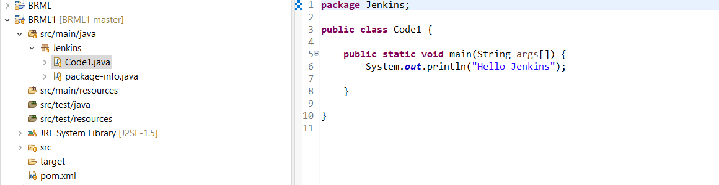

2. Initialize the project folder with. Git

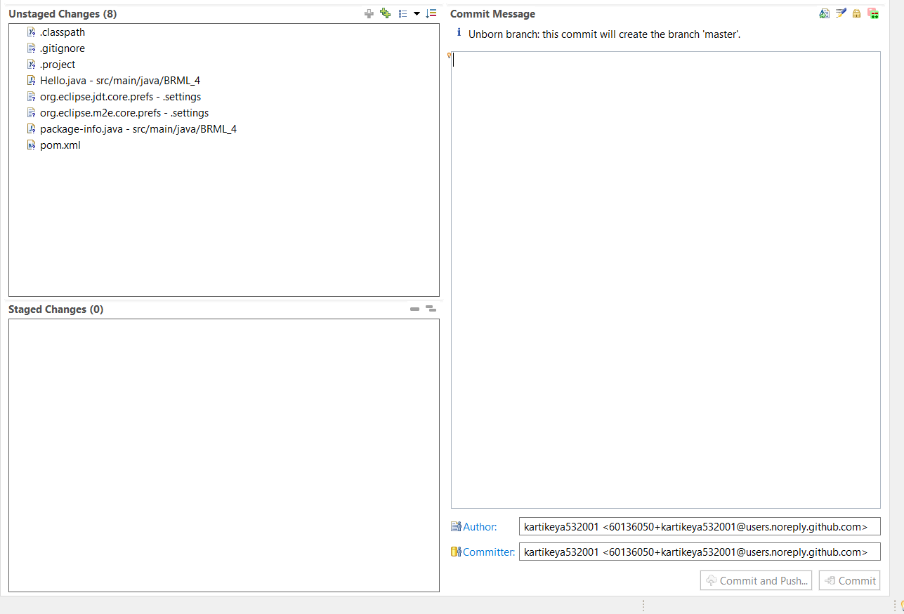

3. Configuring with GitHub credentials and Staging the changes, through eclipse

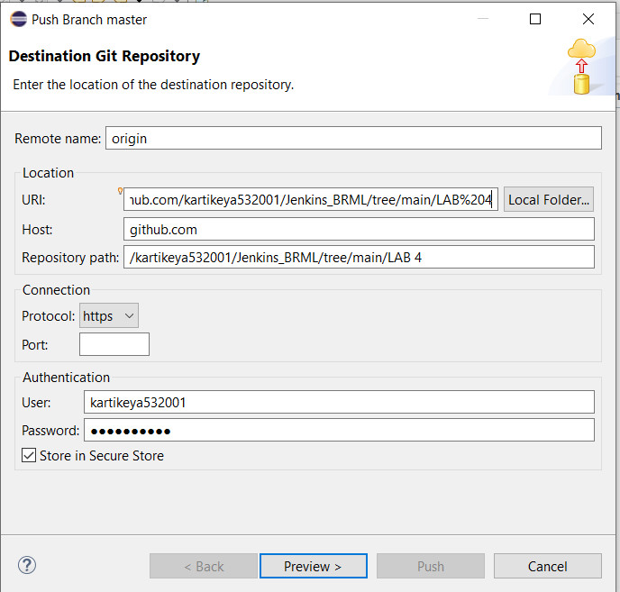

4. Committing and pushing the changes.

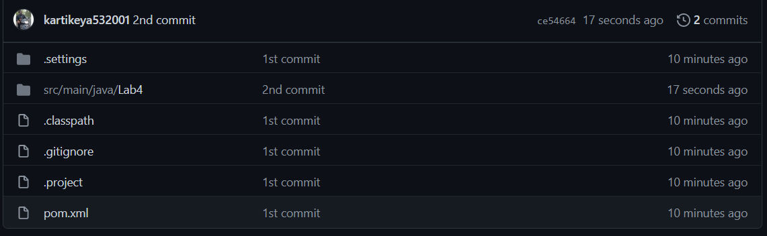

5. Choose a new Item→ Maven Project → Name of the project

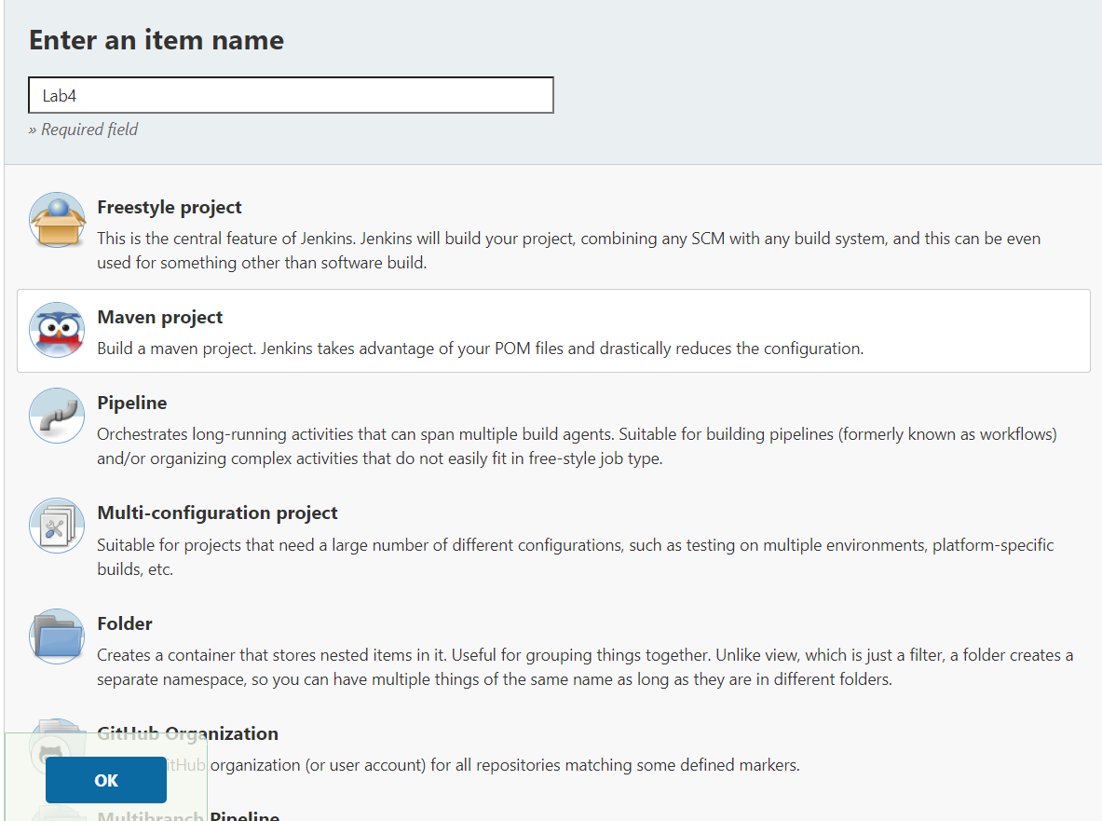

6. Now give the Repository link and schedule the automatic build with POLL SCM

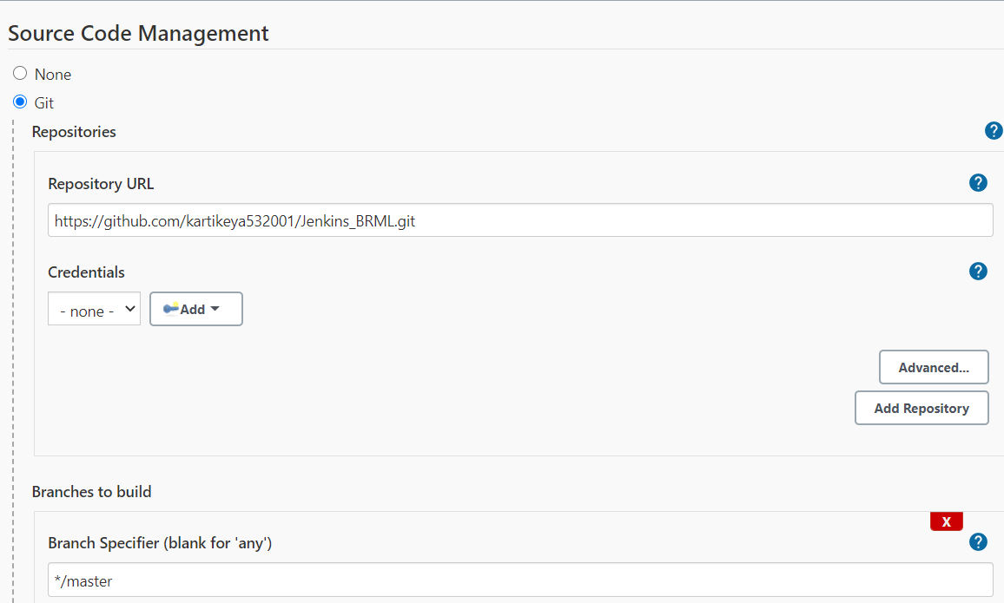

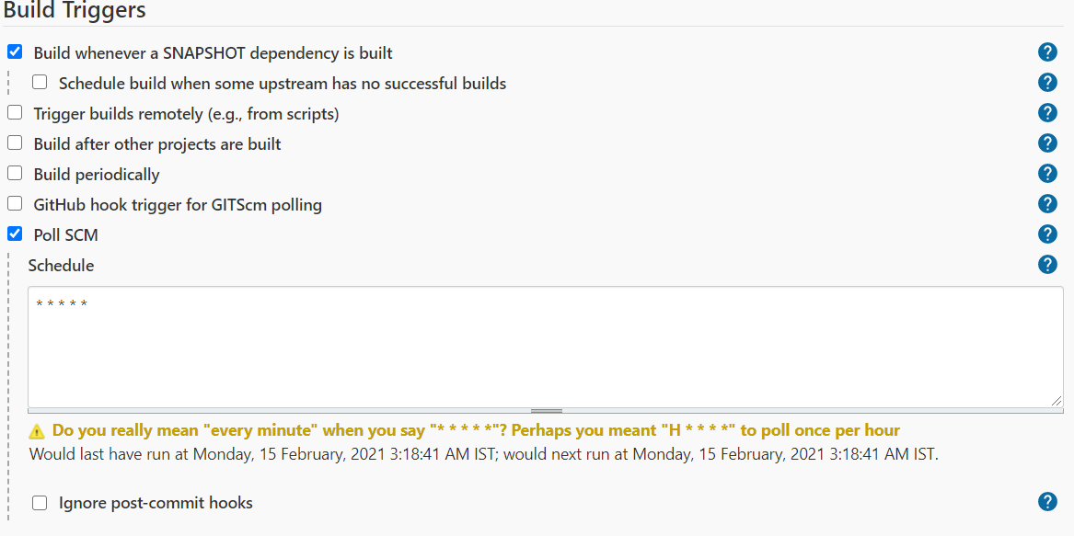

7. Now we can test by committing a new change into the repository and Jenkins will automatically build it.

